CS3500 LAB3 REPORT
Name: Ashish Cherian Thannickal
Roll No: CS23B099
Problem 1 - Page Table Tree Printing in xv6
Changes made/Code added –
- kernel/vm.c – completed the function void vmprint(pagetable_t pagetable) along with helper functions vmprintwalk(pagetable_t pagetable, int level) and printindent(int level). 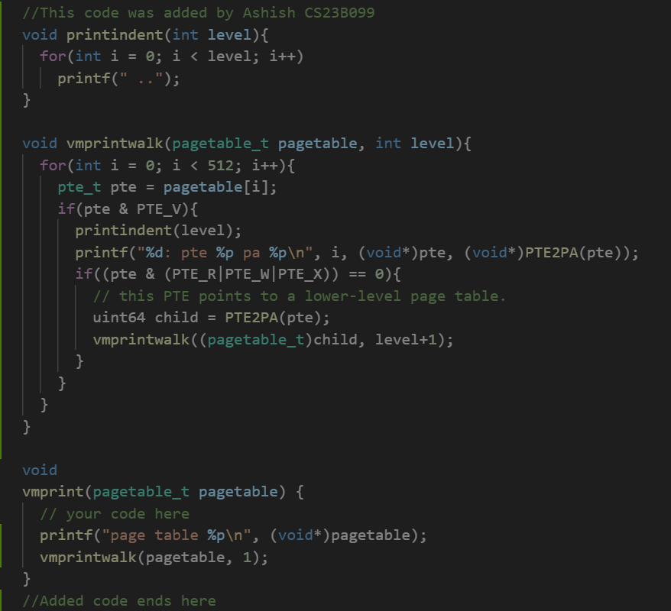
- kernel/exec.c – inserted a call to vmprint in the function int exec(char* path, char** argv) to print the page table for the first user process(pid = 1). 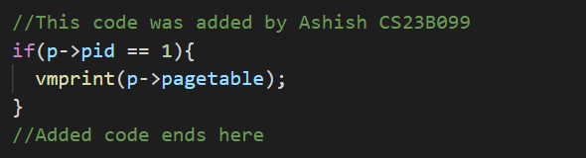
- kernel/defs.c – function prototype for vmprint was already present.
Logic/ Working –
- The vmprint function follows almost exactly the same logic as the freewalk function present in the vm.c file. It goes through each pagetable entry in a pagetable(starting from the root pagetable) and if the entry is valid it prints the entry in the required format.
- For every entry, if the RWX bits are all 0 then the entry is a pointer to a lower level page table and we recursively use that pagetable as root for vmprintwalk.
- This continues until we reach a leaf node where the entry is printed in the required format and the function returns to the caller.

Problem 2 - Optimizing the getpid() System Call in xv6 via Page Table Sharing
Changes made/Code added –
- kernel/proc.h – Added the field struct usyscall* usyscall to the proc struct in proc.h
- kernel/proc.c – Made the following changes in the following functions :
- static struct proc*allocproc(void) : allocated space for the read only page that can be accessed by both kernel and userspace. Also initialized the pid field to the process pid. 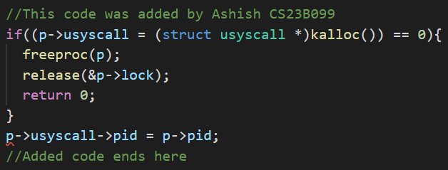
- static void freeproc(struct proc *p): used kfree in order to free up the space used by the common page at USYSCALL. Followed the same pattern used by the trampoline page 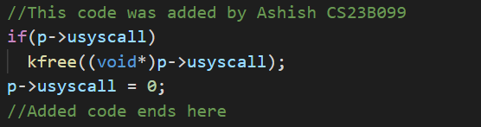
- pagetable_t proc_pagetable(struct proc *p): map the shared read only page to the USYSCALL location using mappages. Followed the same pattern as used for the trampoline page. 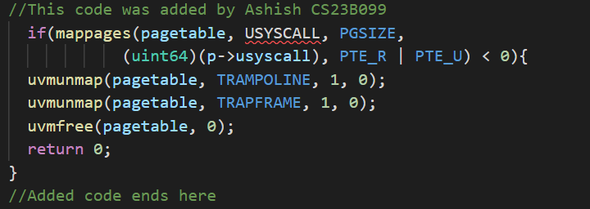
- void proc_freepagetable(pagetable_t pagetable, uint64 sz): Added a line to unmap the part of the pagetable pointed to be USYSCALL.
Logic/ Working –
- The code was implemented very similarly to the code for the trapframe page.
- Whenever a new process is created, allocproc is called and it finds an unused proc and allocates trapframe, and a process pagetable. The modified code also allocates space for the usyscall and initializes it with the pid for the current process.
- Then proc_pagetable maps the virtual addresses for the pages in allocproc. Here we are mapping USYSCALL to a read-only userspace page using mappages .
- This page is now accessible from user mode and thus we can find pid more efficiently without calling an interrupt/ going to kernel to get the pid.
- The USYSCALL page is also freed similar to the trapframe page when the program terminates.
Problem 3 - Detecting Accessed Pages: Implementing pgaccess() in xv6
Changes made/Code added –
- kernel/syscall.h – Added the new syscall number for SYS_pgaccess and set it as 35.
- kernel/syscall.c – added the entry for the syscall as well as added it to the array of function pointers.
- user/user.h – added the function prototype for pgaccess.
- user/usys.pl – added an entry for pgaccess so usys.S creates the relevant stub.
- kernel/riscv.h – added a macro for PTE_A.
- kernel/sysproc.c – added the function definition for uint64 sys_pgaccess(void). 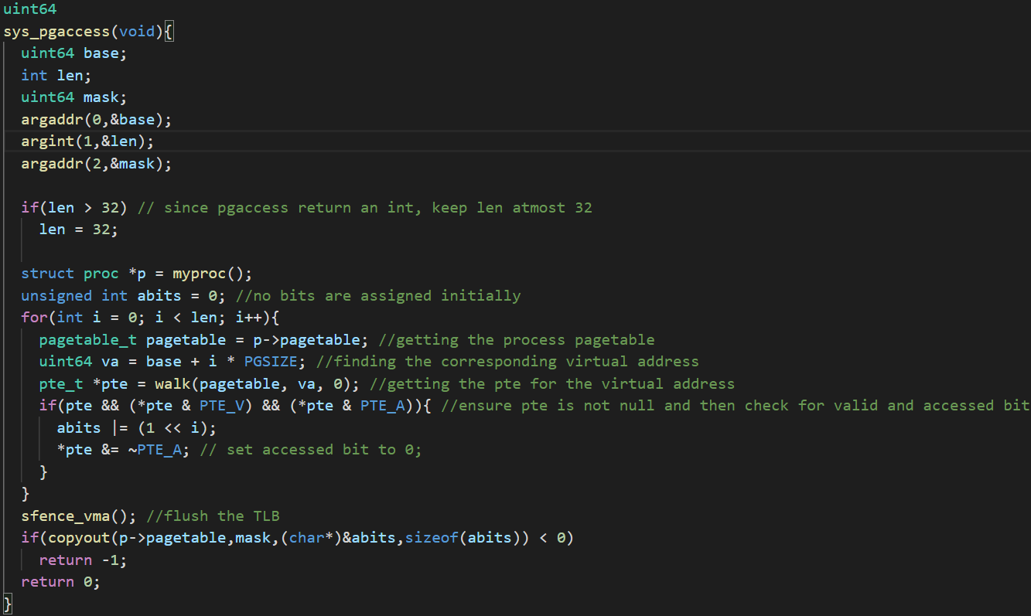
Logic/ Working –
- set up a syscall pgaccess similar to trace for lab2.
- Use the argint and argaddr to get the three arguments for the syscall. Keep a bound on len (32 in this case since the ).
- Now go through the virtual addresses in the range and find the entry corresponding to that address(using the walk function) and if it was accessed, add it to the bitmask and reset the accessed bit to 0, so that future calls to pgaccess do not include the same page.
- Flush the TLB using sfence_vma() as a precaution.
- Now after the bitmask is constructed, using the copyout function copy the bitmask to specified location in the user space (mask).

